The outcome of IMP3 and cyclin D1 expression in colorectal cancer patients: Recurrence and Survival

Salem Youssef Mohamed1, Abeer Hafez 2, Amira Elwan 3, Mohamed I Abdelhamid4, Nabila Hassan Ahmed5, Bader A. Abdelmaksoud3, Abeer M Abdelbary2

¹Gastroenterology and Hepatology Unit, Internal Medicine Department, Faculty of Medicine, Zagazig University, Egypt.

2Pathology Department, faculty of medicine, Zagazig University.

3Clinical Oncology Department, Zagazig University.

4General surgery department, faculty of medicine, Zagazig University.

5Tropical Medicine Department, Zagazig University.

**Corresponding author:** Salem Youssef Mohamed,

Assistant professor of internal medicine, Zagazig University, Egypt.

**Mail:** [**salemyousefmohamed@gmail.com**](mailto:salemyousefmohamed@gmail.com)

**Cell phone: +201147805292.**

**Orcid: 0000-0003-2917-4293**

***Abstract***

Background: Colorectal cancer (CRC) is the third most frequently diagnosed cancer and the fourth top cause of cancer death worldwide. In Egypt, colorectal carcinoma is considered the 7th common cancer, representing 3.47% of male cancers and 3% of female malignancies. A localized CRC can be entirely cured by surgical resection. Metastasis remains the leading cause of cancer mortality. IMP3 is an independent prognostic biomarker that expects metastasis and poor prognosis in the CRC. The upregulation of nuclear cyclin D1 (CCND1) plays an essential role in pathogenesis and metastases of CRC. Objective: We aimed to investigate the expression of IMP3 and Cyclin D1 in colorectal carcinoma and their correlation with other clinicopathological features. **Participants:** 80 formalin-fixed and paraffin-embedded blocks of CRC were obtained from patients who underwent surgical resection. The immunohistochemical expression of IMP3 and Cyclin D1 examined and correlated with clinical-pathological parameters and outcome of the patients. Key Results; overexpression of IMP3 and cyclin D1 was noted in (68.75%) and at (56.25%), respectively. IMP3 expression was significantly correlated with tumor grade (P <0.001), TNM stage (P .040), LVI (p 0.005), cyclin D1 was significantly associated with TNM stage (P<0.001), LN metastasis (P<0.001), DM (P0.004).Conclusions: IMP3 and cyclin d1 were associated with poor prognosis in CRC, and so, they comprise an attractive target for anticancer drug development.

Keywords: IMP3, cyclin D1, colorectal cancer, recurrence, survival

Introduction

Colorectal cancer (CRC) is the third most frequently diagnosed cancer and the fourth top cause of cancer death in the worldwide (Siegel et al. 2018)

In Egypt, colorectal carcinoma is considered the 7th common cancer, representing 3.47% of male cancers and 3% of female malignancies (Metwally et al. 2018).

When the disease is localized, the surgical resection of the primary tumor can be enough for a complete cure, but distant metastasis remains the main reason for treatment failure and cancer fatality (Isella et al. 2015).

CRC commonly sends metastasis to the liver as most of the GIT drainage pass to the hepatic portal venous circulation. More than 50% of patients with CRC have liver metastasis, which is the leading cause of cancer mortality in more than two-thirds of cases [House., et al. 2011).

Insulin-like growth factor II mRNA-binding protein 3 (IMP3) is one of the insulin-like growth factor (IGF) mRNA binding protein (IMP) family members that contain IMP1, IMP2, and IMP3 (Bell., et al. 2013).

Insulin-like growth factor 2 messenger RNA binding protein 3 (IGF2BP3, also known as IMP3) has an essential role in stabilization and trafficking of RNA, cellular growth, and cell migration during embryogenesis (Mueller-Pillasch. et al. 1999).

A range of malignancies as pancreatic, lung, esophageal, thyroid, and gynecological tumors, and melanomas showed IMP3 expression (Findeis-Hosey and, Xu, 2011).

Many studies have decided that IMP3 promotes tumor cell proliferation, adhesion, and invasion (Bell. et al. 2013).

Furthermore, it has been shown that IMP3 expression, determined by immunohistochemistry, has prognostic significance in a variety of cancers, including colorectal cancer (Yuan. et al. 2009).

CCND1 plays an essential role in the cell cycle as it controls the shift of the cell cycle from phase G1 to S phase by pRb mediation. CCND1/Cyclin-Dependent Kinase (CDK) 4–6 complexes initiate the phosphorylation of pRb, and cyclin E/CDK2 complex completes the process in late G1 phase. Alterations in cyclin and CDK expression result in increased cellular proliferation and participate in malignancy **(Yasui. et al. 2006).**

The upregulation of nuclear cyclin D1 (CCND1) plays an essential role in pathogenesis and metastases of CRC (Alao. et al. 2007).

So, we aimed in this study to investigate the expression of IMP3 and Cyclin D1 in colorectal carcinoma and their correlation with other clinicopathological features

**Material and Methods: -**

A prospective cohort study that includes sections from formalin-fixed, paraffin-embedded samples from 80 CRC patients were enrolled in this work. All CRC patients are operated in the General Surgery Department, Faculty of Medicine, Zagazig University, in the period from January 2015 to January 2019. Specimens were processed, diagnosed, graded, and staged by two pathologists in the Pathology Department, Faculty of Medicine, Zagazig University. Patients’ follow-up data all through the study is obtained from the Department of Clinical Oncology and Nuclear Medicine, Faculty of Medicine, Zagazig University.

The local Ethics Committee approved this study.

Our patients were conducted to pathology, internal medicine, surgical and clinical oncology departments, and university hospitals in collaboration with each other as from the period of January 2015 to June 2019 as a retrospective cohort study. At the pathology department, the research includes sections from formalin-fixed, paraffin-embedded samples from 80 CRC patients Specimen sent, processed. Patients' data are collected from patients' records with approval by the local Ethical Committee.

All patients underwent a proper history and examination. Investigations were requested in the form of lab profile and radiological studies such as pelviabdominal ultrasonography, chest x-ray also chest and pelviabdominal computed tomography. Bone scan and PET scan were requested according to clinical scenarios. All patients underwent colonoscopic diagnostic biopsy. Chemotherapy protocols were proposed for our patients who had functional performance status, and adequate organ function in the form of XELOX, Folfox, and single-agent capecitabine was offered as 1st line chemotherapy while FOLFIRI regimen was mostly as the 1st proposed protocol for metastatic and progressed colorectal cancer patients. Fifteen diagnosed rectal cancer patients out of 80 patients who received neoadjuvant chemoradiation. Patients' follow up was to detect disease recurrence and survival outcome.

**Immunohistochemical staining: -**

We used the streptavidin-biotin technique (**Hsu. et al. 1981)**. Paraffin-embedded blocks have been cut into Four-micron thick sections; deparaffinization was done in a sequence of xylene, and rehydration was done in descending grades of alcohol, endogenous peroxidase activity was blocked by placing the part in 0.5% hydrogen peroxide in methanol for 10 min microwave antigen retrieval.

Primary Rabbit polyclonal antibody directed against IMP3 (Thermo Fisher Scientific/Lab Vision Corporation, Rockford, USA. Used in a dilution of 1-100) and rabbit monoclonal anti-Anti-Cyclin D1 antibody [SP4] (ab16663) dilution 1:50). Furthermore, by employing diaminobenzidine (DAB) as the chromogen was added for 30 minutes at room temperature. The secondary antibody was added to sections for 30 minutes. After incubation, the reaction product was seen by diaminobenzidine. In the end, the sections were counterstained with Mayer’s hematoxylin. Negative controls had primary antibody replaced by buffer

**Immunohistochemical evaluation of both markers**

**For Imp3**

Cytoplasmic IMP3 expression was evaluated following the method previously designated by [**Chiste´etal 2014].** The staining intensity was recorded as weak, moderate, or strong. The percentage of positively stained cells was assessed by microscopic examination of the whole stained section. We defined positive IMP3 expression, as considerable brown cytoplasmic staining in more than 5% of tumor cells, no matter the staining intensity.

**For Cyclin D1**

We recorded the intensity of nuclear cyclin D1 expression (no, weak, moderate or strong), and the proportion of positive tumor cells (0 = 0 to 1%, 1 = 2 to 25%, 2 = 26 to 50%, 3 = 51 to 75%) and 4 = > 75%). For further statistical analyses, cyclin D1 expression was dichotomized into negative (no expression and positive (any expression; fraction and intensity**) (Wangefjord S. et al. 2011)**

**Statistical Analysis**

Continuous variables were expressed as the mean ± SD & median (range), and the categorical variables et al. as a number (percentage). Continuous variables were checked for normality by using the Shapiro-Wilk test. Independent samples Student's t-test was used to compare two groups of normally distributed variables, while the Mann Whitney U test was used for non-normally distributed variables. Percent of categorical variables were compared using Pearson’s Chi-square test or Fisher's exact test when it was appropriate. The trend of change in the distribution of relative frequencies between ordinal data was compared using the Chi-square test for trend. The Correlation between immunohistochemical markers was analyzed using Spearman correlation. A p-value <0.05 was considered significant. All statistics were performed using SPSS.

**Results**

**Clinico-pathological results Tab 1**

In this study, we have 80 cases of CRC 56 (70%) of cases were male, and 24 (30%) cases were female, with age ranges from 39 – 72 years with a median (58), 70 (87.5%) cases were Conventional adenocarcinoma and10 (12.5 %) cases were Mucoid carcinoma

**Immunohistochemical Results:**

**IMP3 Results**

IMP3 was expressed in the cytoplasm of cancer cells. In our study IMP3 was shown in 55 (68.75%) cases, IMP3 expression was significantly correlated with tumor grade (P <0.001), TNM stage (P.040), LVI (p 0.005) but we found no significant correlation between IMP3 expression and age, gender, tumor location, and tumor size.

**Cyclin D1 results**

Cyclin D1 was detected in the nucleus of tumor cells. In our study, cyclin D1 was expressed in 45 (56.25%) cases; cyclin D1 was significantly correlated with TNM stage (P<0.001), LN metastasis (P<0.001), DM (P0.004). Nevertheless, we found no significant correlation between cyclin D1expression and age, gender, tumor location, and tumor size, and grade.

IMP3 positive expressed colorectal cancer patients had an inadequate treatment response with significance, p=0.007.

Cyclin D1 and IMP3 positive expressed patients had shown significant worse 3-year DFS (p=0.002 and p <0.001) (95% CI), respectively.

Negative cyclin D1 and IMP3 were associated with a better 3- year -OS with significance (p=0.003 and p <0.001) (95% CI), respectively.

**Table (1):** Clinicopathological features, immunohistochemical markers, treatment, and outcome among the patients.

|  |  |  |  |  |  |  |
| --- | --- | --- | --- | --- | --- | --- |
| Characteristics | All patients (N=80) | |  | Characteristics | All patients (N=80) | |
| No. | % |  | No. | % |
| Gender |  |  |  | Surgery |  |  |
| Male | 56 | 70% |  | No surgery | 10 | 12.5% |
| Female | 24 | 30% |  | Hemicolectomy | 51 | 63.7% |
|  |  |  |  | APR | 19 | 23.8% |
| Age |  |  |  | Neoadjuvant treatment | (N=69) | |
| <50 years | 20 | 25% |  | No | 54 | 78.3% |
| ≥50 years | 60 | 75% |  | Chemoradiation | 15 | 21.7% |
| Site |  |  |  | Adjuvant chemotherapy | (N=70) | |
| Rt colon | 18 | 22.5% |  | No | 10 | 14.3% |
| Lt colon | 32 | 40% |  | Yes | 60 | 85.7% |
| Transverse | 8 | 10% |  |  |  |  |
| Rectum | 22 | 27.5% |  |  |  |  |
| Gross pattern |  |  |  | Chemotherapy for Stage IV | (N=10) | |
| Fungating | 46 | 57.5% |  | FOLFOX | 1 | 10% |
| Annular | 10 | 12.5% |  | XELOX | 1 | 10% |
| Ulcerative | 24 | 30% |  | FOLFIRI | 8 | 80% |
| Tumor size |  |  |  | Response | (N=10) | |
| ≤5cm | 34 | 42.5% |  | PR | 4 | 40% |
| >5cm | 46 | 57.5% |  | SD | 2 | 20% |
|  |  |  |  | PD | 4 | 40% |
| Pathological type |  |  |  | Follow-up duration (months) |  |  |
| Conventioanl | 70 | 87.5% |  | Mean±SD | 30.37 | ±7.10 |
| Mucoid | 10 | 12.5% |  | Median (Range) | 34 | (10 – 36) |
| Grade |  |  |  | Relapse | (N=70) | |
| Grade I | 15 | 18.8% |  | Absent | 30 | 42.9% |
| Grade II | 45 | 56.3% |  | Present | 40 | 57.1% |
| Grade III | 20 | 25% |  |  |  |  |
| LVI |  |  |  | First-line chemotherapy | (N=40) | |
| Absent | 30 | 37.5% |  | 5fu+leucovorin | 4 | 10% |
| Present | 50 | 62.5% |  | Xeloda | 3 | 7.5% |
| T |  |  |  | FOLOFOX | 10 | 25% |
| T1 | 9 | 11.3% |  | XELOX | 20 | 50% |
| T2 | 20 | 25% |  | FOLFIRI | 3 | 7.5% |
| T3 | 39 | 48.8% |  |  |  |  |
| T4 | 12 | 15% |  |  |  |  |
| LN |  |  |  | Second-line chemotherapy | (N=50) | |
| Negative | 30 | 37.5% |  | No | 1 | 2% |
| Positive | 50 | 62.5% |  | Xeloda | 1 | 2% |
|  |  |  |  | FOLOFOX | 2 | 4% |
| DM |  |  |  | XELOX | 12 | 24% |
| Negative | 70 | 87.5% |  | FOLFIRI | 34 | 68% |
| Positive | 10 | 12.5% |  |  |  |  |
|  |  |  |  |  |  |  |
| Stage |  |  |  | Third line chemotherapy | (N=50) | |
| Stage I | 12 | 15% |  | No | 46 | 92% |
| Stage II | 18 | 22.5% |  | Xeloda | 1 | 2% |
| Stage III | 40 | 50% |  | FOLFIRI | 3 | 6% |
| Stage IV | 10 | 12.5% |  |  |  |  |
| Cyclin D1 |  |  |  | Mortality | (N=80) | |
| Negative | 35 | 43.8% |  | Alive | 38 | 47.5% |
| Positive | 45 | 56.2% |  | Died | 42 | 52.5% |
| IMP |  |  |  |  |  | |
| Negative | 25 | 31.2% |  |  |  |  |
| Positive | 55 | 68.8% |  |  |  |  |

Categorical variables were expressed as number (percentage); Continuous variables were expressed as mean ± SD & median (range).

**Table (2):** Relationship between clinicopathological features and immunohistochemical staining of Cyclin D1 and IMP among the studied patients.

|  |  |  |  |  |  |  |  |  |  |  |  |  |  |  |  |
| --- | --- | --- | --- | --- | --- | --- | --- | --- | --- | --- | --- | --- | --- | --- | --- |
| Characteristics | All  patients | |  | Cyclin D1 | | | | | p-value | IMP | | | | | p-value |
| Negative  (N=35) | |  | Positive  (N=45) | | Negative  (N=25) | |  | Positive  (N=55) | |
| (N=80) | |
| No. | (%) | No. | (%) | No. | (%) | No. | (%) | No. | (%) |
| Gender |  |  |  |  |  |  |  |  |  |  |  |  |  |  |  |
| Male | 56 | (70%) |  | 23 | (41.1%) |  | 33 | (58.9%) | 0.461‡ | 18 | (32.1%) |  | 38 | (67.9%) | 0.792‡ |
| Female | 24 | (30%) |  | 12 | (50%) |  | 12 | (50%) | 7 | (29.2%) |  | 17 | (70.8%) |
| Age |  |  |  |  |  |  |  |  |  |  |  |  |  |  |  |
| <50 years | 20 | (25%) |  | 10 | (50%) |  | 10 | (50%) | 0.515‡ | 7 | (35%) |  | 13 | (65%) | 0.676‡ |
| ≥50 years | 60 | (75%) |  | 25 | (41.7%) |  | 35 | (58.3%) | 18 | (30%) |  | 42 | (70%) |
| Site |  |  |  |  |  |  |  |  |  |  |  |  |  |  |  |
| Rt colon | 18 | (22.5%) |  | 8 | (44.4%) |  | 10 | (55.6%) | 0.467‡ | 6 | (33.3%) |  | 12 | (66.7%) | 0.784‡ |
| Lt colon | 32 | (40%) |  | 15 | (46.9%) |  | 17 | (53.1%) | 11 | (34.4%) |  | 21 | (65.6%) |
| Transverse | 8 | (10%) |  | 5 | (62.5%) |  | 3 | (37.5%) | 3 | (37.5%) |  | 5 | (62.5%) |
| Rectum | 22 | (27.5%) |  | 7 | (31.8%) |  | 15 | (68.2%) | 5 | (22.7%) |  | 17 | (77.3%) |
| Gross pattern |  |  |  |  |  |  |  |  |  |  |  |  |  |  |  |
| Fungating | 46 | (57.5%) |  | 20 | (43.5%) |  | 26 | (56.5%) | 0.563‡ | 12 | (26.1%) |  | 34 | (73.9%) | 0.324‡ |
| Annular | 10 | (12.5%) |  | 3 | (30%) |  | 7 | (70%) | 5 | (50%) |  | 5 | (50%) |
| Ulcerative | 24 | (30%) |  | 12 | (50%) |  | 12 | (50%) | 8 | (33.3%) |  | 16 | (66.7%) |
| Tumor size |  |  |  |  |  |  |  |  |  |  |  |  |  |  |  |
| ≤5cm | 34 | (42.5%) |  | 16 | (47.1%) |  | 18 | (52.9%) | 0.608‡ | 10 | (29.4%) |  | 24 | (70.6%) | 0.760‡ |
| >5cm | 46 | (57.5%) |  | 19 | (41.3%) |  | 27 | (58.7%) | 15 | (32.6%) |  | 31 | (67.4%) |
| Pathological type |  |  |  |  |  |  |  |  |  |  |  |  |  |  |  |
| Conventioanl | 70 | (87.5%) |  | 30 | (42.9%) |  | 40 | (57.1%) | 0.741‡ | 23 | (32.9%) |  | 47 | (67.1%) | 0.494‡ |
| Mucoid | 10 | (12.5%) |  | 5 | (50%) |  | 5 | (50%) | 2 | (20%) |  | 8 | (80%) |
| Grade |  |  |  |  |  |  |  |  |  |  |  |  |  |  |  |
| Grade I | 15 | (18.8%) |  | 11 | (73.3%) |  | 4 | (26.7%) | 0.154§ | 11 | (73.3%) |  | 4 | (26.7%) | <0.001§ |
| Grade II | 45 | (56.3%) |  | 15 | (33.3%) |  | 30 | (66.7%) | 12 | (26.7%) |  | 33 | (73.3%) |
| Grade III | 20 | (25%) |  | 9 | (45%) |  | 11 | (55%) | 2 | (10%) |  | 18 | (90%) |
| LVI |  |  |  |  |  |  |  |  |  |  |  |  |  |  |  |
| Absent | 30 | (37.5%) |  | 13 | (43.3%) |  | 17 | (56.7%) | 0.954‡ | 15 | (50%) |  | 15 | (50%) | 0.005‡ |
| Present | 50 | (62.5%) |  | 22 | (44%) |  | 28 | (56%0 | 10 | (20%) |  | 40 | (80%) |
| T |  |  |  |  |  |  |  |  |  |  |  |  |  |  |  |
| T1 | 9 | (11.3%) |  | 3 | (33.3%) |  | 6 | (66.7%) | 0.496§ | 3 | (33.3%) |  | 6 | (66.7%) | 0.602§ |
| T2 | 20 | (25%) |  | 11 | (55%) |  | 9 | (45%) | 9 | (45%) |  | 11 | (55%) |
| T3 | 39 | (48.8%) |  | 18 | (46.2%) |  | 21 | (53.8%) | 8 | (20.5%) |  | 31 | (79.5%) |
| T4 | 12 | (15%) |  | 3 | (25%) |  | 9 | (75%) | 5 | (41.7%) |  | 7 | (58.3%) |
| LN |  |  |  |  |  |  |  |  |  |  |  |  |  |  |  |
| Negative | 30 | (37.5%) |  | 22 | (73.3%) |  | 8 | (26.7%) | <0.001‡ | 9 | (30%) |  | 21 | (70%) | 0.852‡ |
| Positive | 50 | (62.5%) |  | 13 | (26%) |  | 37 | (74%) | 16 | (32%) |  | 34 | (68%) |
| DM |  |  |  |  |  |  |  |  |  |  |  |  |  |  |  |
| Negative | 70 | (87.5%) |  | 35 | (50%) |  | 35 | (50%) | 0.004‡ | 19 | (27.1%) |  | 51 | (72.9%) | 0.063‡ |
| Positive | 10 | (12.5%) |  | 0 | (0%) |  | 10 | (100%) | 6 | (60%) |  | 4 | (40%) |
| Stage |  |  |  |  |  |  |  |  |  |  |  |  |  |  |  |
| Stage I | 12 | (15%) |  | 10 | (83.3%) |  | 2 | (16.7%) | <0.001§ | 6 | (50%) |  | 6 | (50%) | .040§ |
| Stage II | 18 | (22.5%) |  | 12 | (66.7%) |  | 6 | (33.3%) | 3 | (16.7%) |  | 15 | (83.3%) |
| Stage III | 40 | (50%) |  | 13 | (32.5%) |  | 27 | (67.5%) | 10 | (25%) |  | 30 | (75%) |
| Stage IV | 10 | (12.5%) |  | 0 | (0%) |  | 10 | (100%) | 6 | (60%) |  | 4 | (40%) |
| Cyclin D1 |  |  |  |  |  |  |  |  |  |  |  |  |  |  |  |
| Negative | 35 | (43.8%) |  |  |  |  |  |  |  | 12 | (34.3%) |  | 23 | (65.7%) | 0.605‡ |
| Positive | 45 | (56.2%) |  |  |  |  |  |  | 13 | (28.9%) |  | 32 | (71.1%) |
| IMP |  |  |  |  |  |  |  |  |  |  |  |  |  |  |  |
| Negative | 25 | (31.2%) |  | 12 | (48%) |  | 13 | (52%) | 0.605‡ |  |  |  |  |  |  |
| Positive | 55 | (68.8%) |  | 23 | (41.8%) |  | 32 | (58.2%) |  |  |  |  |  |

Categorical variables were expressed as number (percentage); ‡ Chi-square test; § Chi-square test for trend; p<0.05 is significant.

**Table (3):** Relation between immunohistochemical staining of Cyclin D1 and IMP and outcome among the studied colorectal carcinoma patients (N=80).

|  |  |  |  |  |  |  |  |  |  |  |  |  |  |  |  |
| --- | --- | --- | --- | --- | --- | --- | --- | --- | --- | --- | --- | --- | --- | --- | --- |
| Outcome | All  Patients | |  | Cyclin D1 | | | | | p-value | IMP | | | | | p-value |
| Negative | |  | Positive | | Negative | |  | Positive | |
| No. | (%) | No. | (%) | No. | (%) | No. | (%) | No. | (%) |
| Response | (N=10) | |  |  | |  | (N=10) | |  | (N=6) | |  | (N=4) | |  |
| PR | 4 | (40%) |  |  |  |  | 4 | (40%) | ----- | 4 | (66.7%) |  | 0 | (0%) | 0.007‡ |
| SD | 2 | (20%) |  |  |  |  | 2 | (20%) | 2 | (33.3%) |  | 0 | (0%) |
| PD | 4 | (40%) |  |  |  |  | 4 | (40%) | 0 | (0%) |  | 4 | (100%) |
| Relapse | (N=70) | |  | (N=35) | |  | (N=35) | |  | (N=19) | |  | (N=51) | |  |
| Absent | 30 | (42.9%) |  | 21 | (60%) |  | 9 | (25.7%) | 0.004‡ | 19 | (100%) |  | 11 | (21.6%) | <0.001‡ |
| Present | 40 | (57.1%) |  | 14 | (40%) |  | 26 | (74.3%) | 0 | (0%) |  | 40 | (78.4%) |
| DFS |  | |  |  | |  |  | |  |  | |  |  | |  |
| Mean DFS  (95%CI) | 20.98months  (17.89-24.07) | |  | 25.65months  (21.42-29.88) | |  | 16.31months  (12.37-20.25) | | 0.002† | 36months | |  | 15.39months  (12.34-18.44) | | <0.001† |
| Median DFS  (95%CI) | 14months  (11.77-16.22) | |  | NR | |  | 10months  (7.83-12.16) | | NR | |  | 10months  (10-12) | |
| 6month DFS | 88.5% | |  | 94.3% | |  | 82.9% | | 100% | |  | 84.3% | |
| 12month DFS | 51.4% | |  | 65.7% | |  | 37.1% | | 100% | |  | 33.3% | |
| 24month DFS | 42.9% | |  | 65.7% | |  | 25.7% | | 100% | |  | 21.6% | |
| 36month DFS | 42.9% | |  | 60% | |  | 25.7% | | 100% | |  | 21.6% | |
| Mortality | (N=80) | |  | (N=35) | |  | (N=45) | |  | (N=25) | |  | (N=55) | |  |
| Alive | 38 | (47.5%) |  | 23 | (65.7%) |  | 15 | (33.3%) | 0.004‡ | 22 | (88%) |  | 16 | (29.1%) | <0.001‡ |
| Died | 42 | (52.5%) |  | 12 | (34.3%) |  | 30 | (66.7%) | 3 | (12%) |  | 39 | (70.9%) |
| OS |  | |  |  | |  |  | |  |  | |  |  | |  |
| Mean OS  (95%CI) | 30.37months  (28.82-31.92) | |  | 32.97months  (31.24-34.69) | |  | 28.35months  (26.12-30.58) | | 0.003† | 33.92months  (31.64-36.19) | |  | 28.76months  (26.91-30.61) | | <0.001† |
| Median OS  (95%CI) | 34months | |  | NR | |  | 28months  (25.37-30.62) | | NR | |  | 28months  (25.58-30.41) | |
| 12month OS | 96.3% | |  | 100% | |  | 93.3% | | 100% | |  | 94.5% | |
| 24month OS | 78.8% | |  | 88.6% | |  | 71.1% | | 88% | |  | 74.5% | |
| 36month OS | 47.5% | |  | 65.7% | |  | 33.3% | | 88% | |  | 29.1% | |

Continuous variables were expressed as mean (95%CI) and median (95%CI); categorical variables were expressed as number (percentage); NR: not reached yet; ‡ Chi-square test; † Log-rank analysis; p<0.05 is significant.

|  |  |
| --- | --- |
|  |  |
| **(A)** | **(D)** |
|  |  |
| **(B)** | **(E)** |
|  |  |
| **(C)** | **(F)** |

**Fig (1):** Kaplan Meier plot for colorectal carcinoma patients (N=80), Left panel: Disease-Free Survival, Right panel; Overall Survival; (A & D) All studied patients, (B & E) Stratified by Cyclin D1 and (C & F) Stratified by IMP.

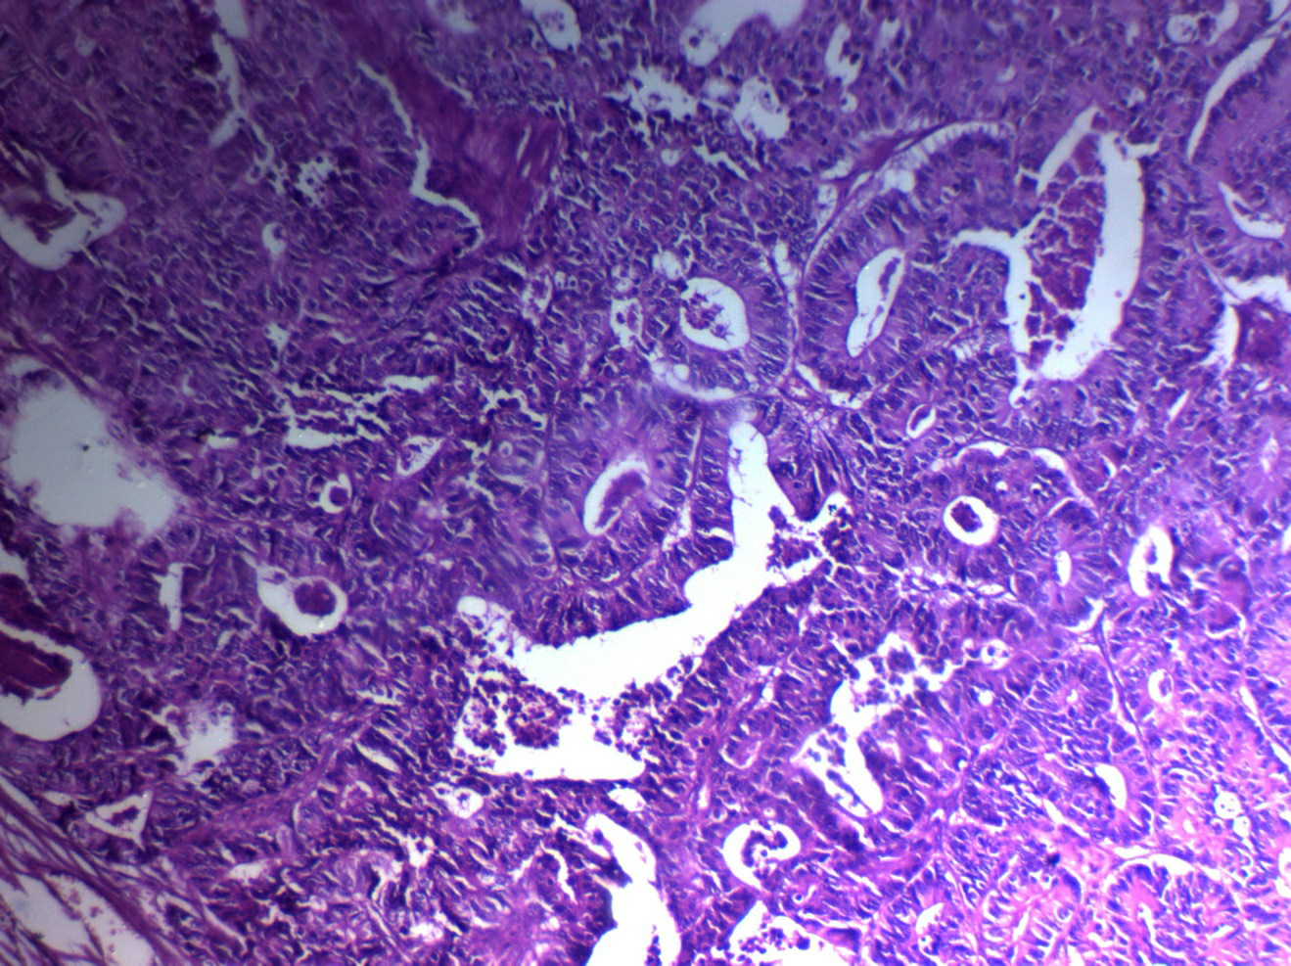

**Fig 2: Moderately differentiated colon cancer, H&E** **ABC, DABx200).**

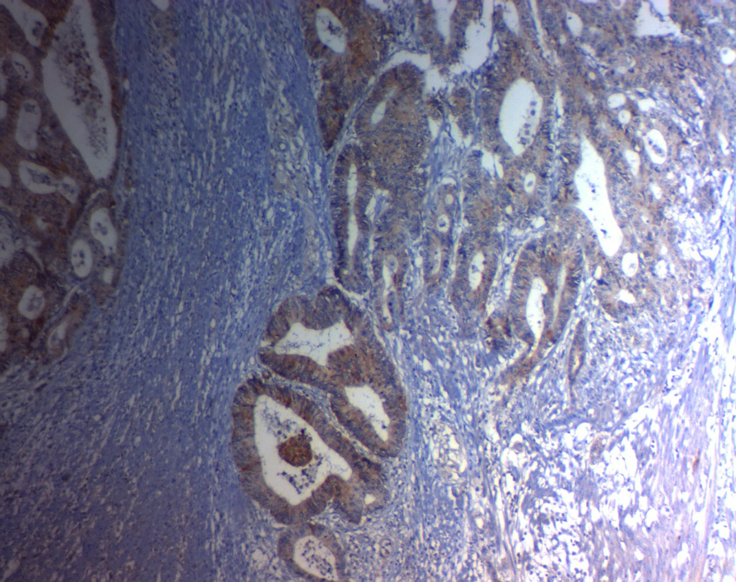

**A**

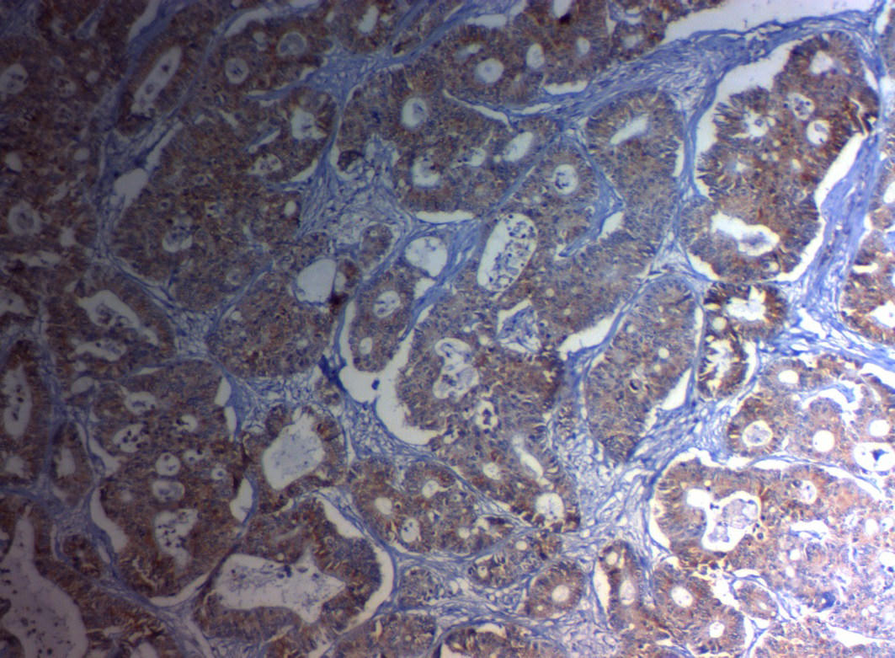**B**

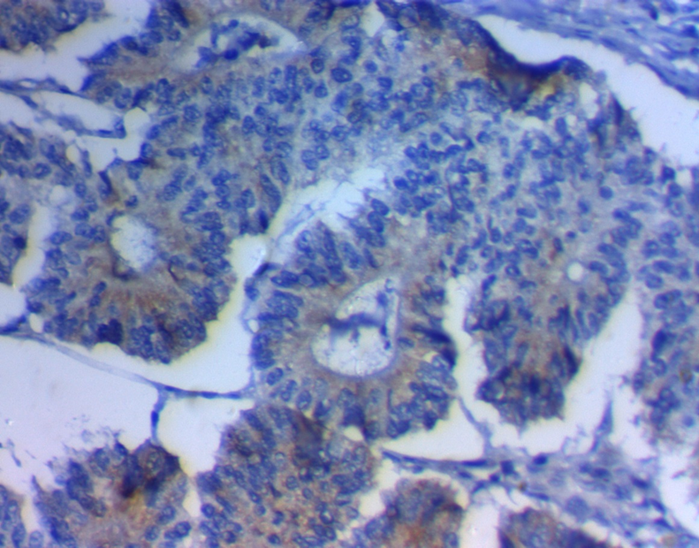

**C**

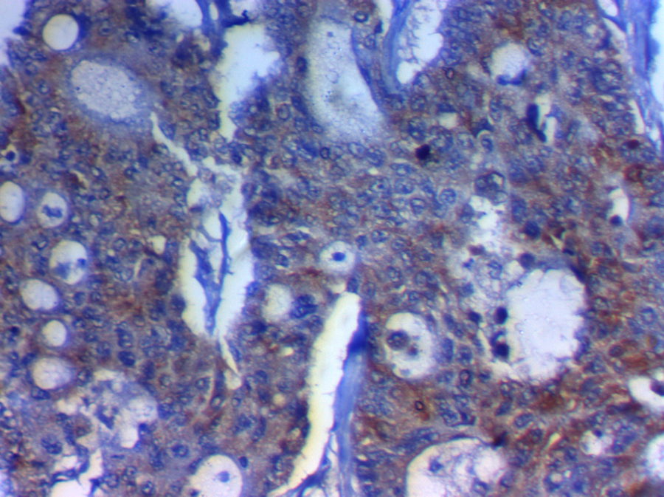

**D**

Fig 3: IMP3 expression in cancer colon

1. Positive moderate cytoplasmic IMP3 expression in well-differentiated colonic carcinoma (ABC, DABx200).
2. Positive strong cytoplasmic IMP3 expression in moderate differentiated colonic carcinoma (ABC, DABx200).
3. Positive strong cytoplasmic IMP3 expression in moderate differentiated colonic carcinoma (ABC, DABx400).
4. Positive strong cytoplasmic IMP3 expression in high grade colonic carcinoma (ABC, DABx400).

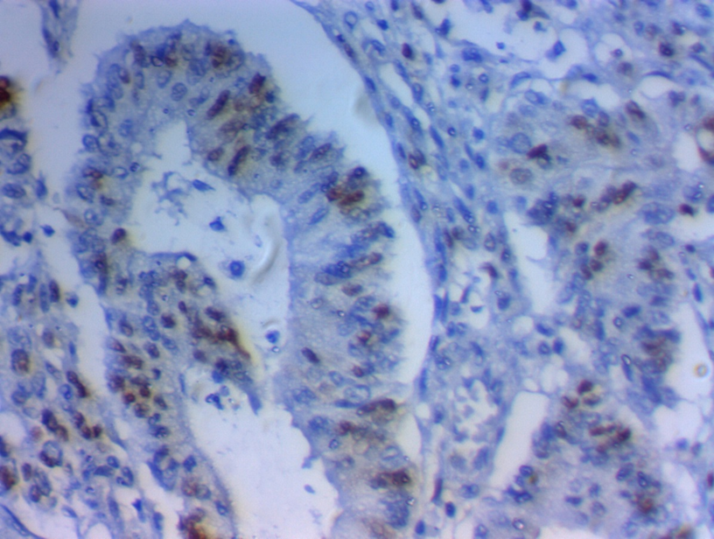

**A**

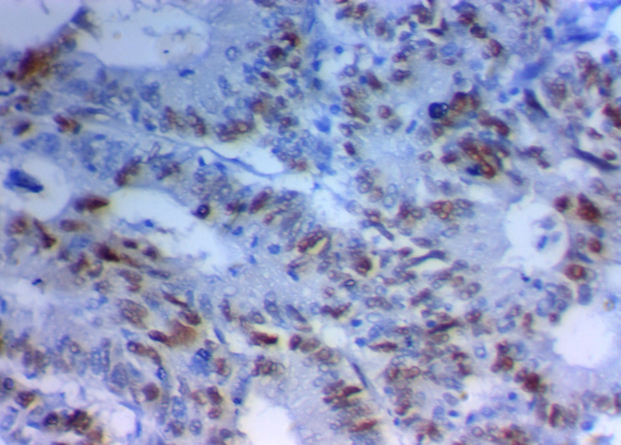

**B**

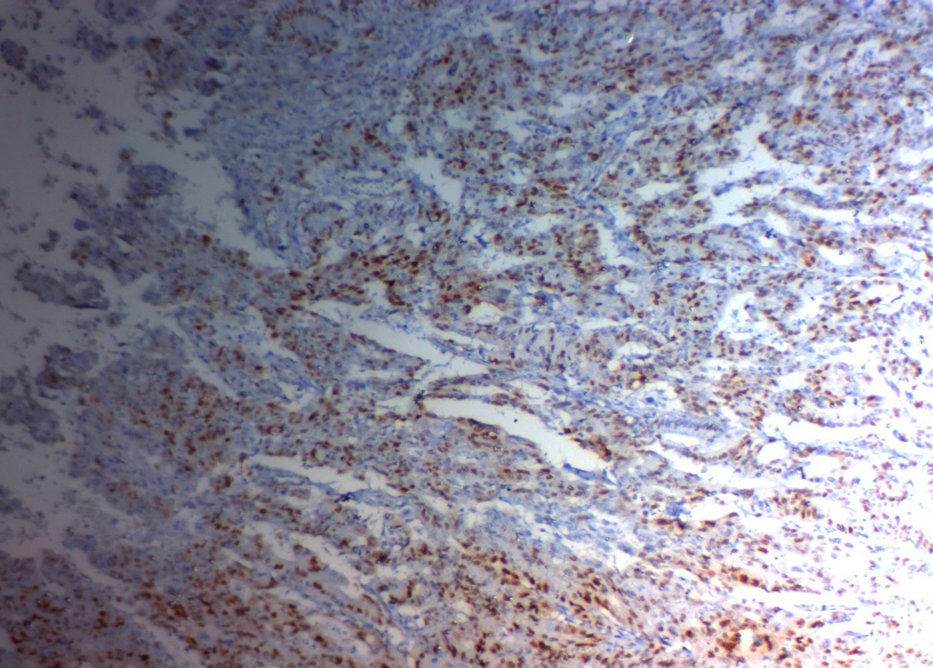

**C**

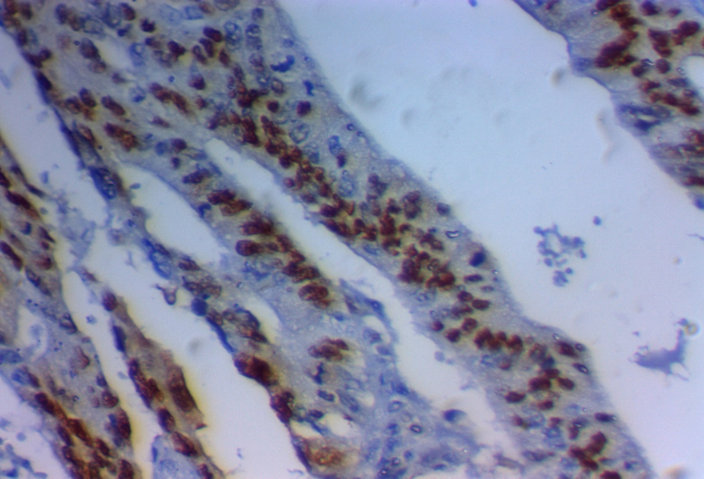

D

Fig 4: cyclin D1 expression in cancer colon

1. Positive moderate nuclear cyclin D1 expression in moderate differentiated colonic carcinoma (ABC, DABx400)
2. Positive strong nuclear cyclin D1 expression in moderate differentiated colonic carcinoma (ABC, DABx400)
3. Positive strong nuclear cyclin D1 expression in high grade colonic carcinoma (ABC, DABx100)
4. Positive strong nuclear cyclin D1 expression in high grade colonic carcinoma (ABC, DABx400)

**Discussion**

A localized CRC can be wholly cured by surgical resection. Metastases remain the leading cause of cancer mortalit**y (Torre, et al. 2015).**

IMP3 is an independent prognostic biomarker that expects metastasis and poor prognosis in CRC **(Lochhead. et al. 2012).**

IMP3 is considered a novel biomarker that can differentiate normal from malignant tissue in a variety of organ systems **(Findeis-Hosey JJ, Xu H, 2011).**

We have 80 cases of colorectal carcinoma 15 cases were GI, 45 cases were GII, and 20 cases were GIII, IMP3 was expressed in 55 (68.75%) cases, also in the study made by **Huang et al. IMP3** was pathology, in (72.3%) of tumor cells, but in the survey made by **Wei et al** IMP3 was shown in (83.1%) of cases, but in the review made by **Lochhead et al** IMP3 was expressed only in 35% of colorectal cancer cases. this variation in the percentage of expression may be due use different primary antibodies. We found that IMP3 expression was significantly correlated with grade of tumor (P <0.001)as the expression increased with grade progression as it was expressed in (26.7%)of GI and (73.3%)of GII and (90%)of GIII; this in agreement with the work made by **Wei et al** who found IMP3 significantly correlated with grade in a resection specimen P= (0.043) and also in the study made by **Lochhead et al** who found a significant correlation between Imp3 expression and degree of tumor (P = 0.0003), but in contrary to what reported by **Huang et al** who failed to find a significant correlation between Imp3 expression and grade of tumor p= 0.122.

In this study, we also found a significant correlation between Imp3 expression and TNM stage (P <0.001), LVI (p 0.005), this results parallel to **Wei et al** who found a substantial correlation between Imp3 expression and TNM stage (P = 0.007), LN metastases (P= 0.023), T classification (P = 0.035). This also in agreement with the study made by **Yuan et al.,** who found a significant correlation between Imp3 expression and high-stage tumor (P = 0.0417), lymph node metastasis (P = 0.0232).

In our study, we found no meaningful relationship between IMP3 expression and age, gender, tumor location, and tumor size. Results similar to that of both **Wei et al.** and **Huang et al**. but in adversity with the results of **Yuan et al.,** who found a significant correlation between IMP3 expression and large tumor size (P = 0.0452).

As regards the results of cyclin D1, we found that cyclin D1 was expressed in 45 (56.25%) cases, but in the survey made by **Bahnassy, et al.** cyclin D 1 was shown at 68.3%also in the review made by **Salem et al.** it was revealed in 48.3%. We found that cyclin D1 expression was significantly correlated with TNM stage (P<0.001), LN metastasis (P<0.001), DM (P0.004). ). This agrees with the study made by **Salem et al.,** who found a significant correlation between Cyclin D1 expression and the presence of lymph node metastases (P = 0.000), distant metastasis (p = 0.029). Also, in the study made by **Van Wangenheim et al.** proved that cyclin D1 was associated with unlucky clinicopathological features of CRC. However, in the survey made by **Al-Maghrabi. et al.** found no association between Cyclin D1 expression and clinicopathological characteristics except with lymphovascular invasion. Nevertheless, the results of both **Holland et al**. & **Ogino et al**. were contrary to our findings as they have decided that cyclin D1overexpression is associated with good prognosis; moreover, they have found that cyclin D1-expressing tumors are less destructive than tumors with reduced cyclin D1 expression.

In our study, we found no significant correlation between the expressions of both markers despite increase expression of both markers in high stage. This may be due to different numbers of positive cases in each pen as IMP3 expressed in 55 cases, but Cyclin D showed only in 45 cases.

Consistent with our study, positive expressed IMP3 patients had shown significant worse 3 -year-DFS= p <0.001 and associated with worse 3- year- OS with significance. Yang et al., 2009 observed worse 5 -year- survival, P=0.0012 in IMP3 positive patients and Li et al., 2009, demonstrated poor prognosis and colon cancer progression and poor survival prediction in CRCs patients who had a positive IMP3 expression in tumor cells (P=0.02) (**Yuan et al. and Li et al**).

**Lochhead et al**., 2012 had shown that IMP3 was an independent prognostic biomarker as it predicted metastasis and poor prognostic CRC outcome.

Huang et al., observed that patients with positive IMP3 expression in tumor cells had a more mediocre survival rate in comparison with patients with negative IMP3 expression in tumor cells but not shown statistically significant association between stromal expression of IMP3 and survival rate, demonstrated reduced survival rates for patients with a stromal expression of IMP3 (P=0.06) (**Huang et al. 2017**).

**A. M. Salem et al., 2018** which reported worse 3year DFS and OS with significance P<0.001and P<0.003 respectively in positive cyclin D1 expression and this utterly consistent with our results regards cyclin D1 as we also demonstrated worse 3year DFS and OS with significance p=0.002 and p=0.003 respectively.

Bahnassy et al., 2004 and Maeda et al., 1998 observed that cyclin D1 overexpression has been associated with poor prognosis 8-9, but Wangefjord et al. 2011 disagreed with us, as he found that cyclin D1 expression was associated with a more favorable outcome for CRC male patients, but not for female, this may be due to the larger sample size of studied patients and different patient characteristics (**Wangefjord et al. 2011**).

**Li et al., 2014** reported a meta-analysis, which investigated cyclin D1 expression significance among Asian and non-Asian colorectal cancer patients and for prediction of the outcome, and showed that high cyclin D1 overexpression was associated with poor OS p<0.001 in 21 studies and associated with worse DFS in 10 studies P=0.001.

In our research, we agree with **Van et al., 2013 and Ahmed et al., 2014** which demonstrated that the multidisciplinary expansion in the use of preoperative chemotherapy, radiation, and target therapy advances are in favor of disease recurrence reduction and high-risk disease survival benefits in positive expressed IMP3 (**van de Velde al 2013 and Ahmed et al. 2014).**

**Conclusions:** IMP3 and cyclin D1 were associated with poor prognosis in the CRC, and so, they comprise an attractive target for anticancer drug development.

**Authors' contributions:** "M, SY and I, H, A wrote the main manuscript and E, A and A, M and A, N prepared figures. A, B, and A, A revise patients, and methods. All authors reviewed the manuscript".

**The Institutional Review Board** approves this study of the Faculty of Medicine Zagazig University. This work was done according to the STROBE guidelines.

**Patients consent**: a written, approved consent was taken from the patients or their relatives to participate in this study.

**Conflicts of interest**

There are no conflicts of interest.

**Acknowledgments:** not relevant.

**References**

1-Siegel RL, Miller KD, Jemal A. Cancer statistics, 2018. CA Cancer J Clin 2018; 68: 7-30.

2-Metwally IH, Shetiwy M, Elalfy AF, Abouzid A, Saleh SS, Hamdy M. Epidemiology, and survival of colon cancer among Egyptians: a retrospective study. Journal of Coloproctology (Rio de Janeiro). 2018 Mar;38(1):24-9.

3-Isella C, Terrasi A, Bellomo SE, Petti C, Galatola G, Muratore A, Mellano A, Senetta R, Cassenti A, Sonetto C, et al: Stromal contribution to the colorectal cancer transcriptome. Nat Genet. 2015; 47: 312‑319.

4-House MG, Kemeny NE, Gonen M, Fong Y, Allen PJ, Paty PB, DeMatteo RP, Blumgart LH, Jarnagin WR, D’Angelica MI. Comparison of adjuvant systemic chemotherapy with or without hepatic arterial infusional chemotherapy after hepatic resection for metastatic colorectal cancer. Ann Surg. 2011; 254: 851-856.

5-Bell JL, Wachter K, Muhleck B, Pazaitis N, Kohn M, Lederer M, Huttelmaier S. Insulin-like growth factor 2 mRNA-binding proteins (IGF2BPs): post-transcriptional drivers of cancer progression? Cell Mol Life Sci. 2013; 70: 2657-2675.

6- Mueller-Pillasch F, Pohl B, Wilda M, et al. Expression of the highly conserved RNA binding protein KOC in embryogenesis. Mech Dev. 1999; 88:95–9. [PubMed: 10525192]

7-Findeis-Hosey JJ, Xu H. The use of insulin-like growth factor-II messenger RNA binding protein-3 in diagnostic pathology. Hum Pathol. 2011; 42:303–14. [PubMed: 20970161]

8-Yuan RH, Wang CC, Chou CC, et al. Diffuse expression of RNA-binding protein IMP3 predicts high-stage lymph node metastasis and poor prognosis in colorectal adenocarcinoma. Ann Surg Oncol. 2009; 16:1711–9. [PubMed: 19357927]

9-Yasui M, Yamamoto H, Ngan CY, Damdinsuren B, Sugita Y, Fukunaga H, et al. Antisense to cyclin D1 inhibits vascular endothelial growth factor-stimulated growth of vascular endothelial cells: implication of tumor vascularization. Clin Cancer Res. 2006;12(15):4720–9.

10-Alao JP. The regulation of cyclin D1 degradation: roles in cancer development and the potential for therapeutic invention. Mol Cancer. 2007;6:24

11-Use of avidin-biotin-peroxidase complex (ABC) in immunoperoxidase techniques: a comparison between ABC and unlabeled antibody (PAP) procedures.

Hsu SM, Raine L, Fanger H.J Histochem Cytochem. 1981 Apr; 29(4) 577-580

DOI: 10.1177/29.4.6166661, PMID: 6166661.

12- M Chiste´, J Alexis, M Recine. IMP3 Expression in Serous Tumors of the Ovary. Appl Immunohistochem Mol Morphol. 2014 Oct;22(9):658-62.

13- Wangefjord S, Manjer J, Gaber A, Nodin B, Eberhard J, and Jirström K: Cyclin D1 expression in colorectal cancer is a favorable prognostic factor in men but not in women prospective, population-based cohort study. Biology of Sex Differences 2011, 2:10.

14-Torre LA, Bray F, Siegel RL, Ferlay J, Lortet‑Tieulent J, and Jemal A: Global cancer statistics, 2012. CA Cancer J Clin.2015; 65: 87‑108.

15-Lochhead P, Imamura Y, Morikawa T, Kuchiba A, Yamauchi M, Liao X, Qian ZR, Nishihara R, Wu K, Meyerhardt JA, Fuchs CS, Ogino S. Insulin-like growth factor 2 messenger RNA binding protein 3 (IGF2BP3) is a marker of unfavorable prognosis in colorectal cancer. Eur J Cancer 2012; 48: 3405-3413.

16- Huang X, Wei Q, Liu J, Niu H, Xiao G, Liu L: Analysis of IMP3 expression in primary tumor and stromal cells in patients with colorectal cancer. Oncology letters. 2017; 14: 7304-7310.

17-Wei Q, Huang X, Fu B, Liu J, Zhong L, Yang Q, Zhao T: IMP3 expression in biopsy specimens of colorectal cancer predicts lymph node metastasis and TNM stage. Int J Clin Exp Pathol. 2015;8(9):11024-11032.

18- Bahnassy, A.A., Zekri, A.R., El-Houssini, S., et al: Cyclin A and Cyclin D1 as Significant Prognostic Markers in Colorectal Cancer Patients. BMC Gastroenterology. 2004;4, 22. https://doi.org/10.1186/1471-230X-4-22

19-Salem AM, Elfeky MA, Nawar N, Alattar AZ, Elekiabi OA, Elaidy MM. Prognostic Value of Combined; Cox-2, Cyclin D1, and P21 Expression in Colorectal Cancer (CRC) Patients: An Immunohistochemical Study. Open Journal of Pathology. 2018 Jun 27;8(03):106.

20-Van Wangenheim, C., Monig, S., Schneider, P., et al: p16, Cyclin D1 and Rb Expression in Colorectal Carcinomas: Correlations with Clinico-Pathological Parameters and Prognosis. Molecular Medicine Reports. 2008;1, 27-32.

21-- Al-Maghrabi J, Mufti S, Gomaa W, Buhmeida A, Al-Qahtani M, Al-Ahwal M: Immunoexpression of cyclin D1 in colorectal carcinomas is not correlated with survival outcome. Journal of Microscopy and Ultrastructure. 2015;3 62-67

22- Holland, T.A., Elder, J., McCloud, J.M., et al: Subcellular Localisation of Cyclin D1 Protein in Colorectal Tumours Is Associated with p21 (WAF1/CIP1) Expression and Correlates with Patient Survival. International Journal of Cancer. 2001; 95, 302-306.

https://doi.org/10.1002/1097 0215(20010920)95:5<302::AID-IJC1052>3.0.CO;2-#

23-Ogino, S., Nosho, K., Irahara, N., et al: A Cohort Study of Cyclin D1 Expression and Prognosis in 602 Colon Cancer Cases. Clinical Cancer Research. 2009;15, 4431-4438. https://doi.org/10.1158/1078-0432.CCR-08-3330

24-Li D, Yan D, Tang H, Zhou C, Fan J, Li S, Wang X, Xia J, Huang F, Qiu G, Peng Z. IMP3 is a novel prognostic marker that correlates with colon cancer progression and pathogenesis. Annals of surgical oncology. 2009 Dec 1;16(12):3499-506.

25- van de Velde CJ, Aristei C, Boelens PG, Beets Tan RG, Blomqvist L, Borras JM, van den Broek CB, Brown G, Coebergh JW, Cutsem EV, et al: EURECCA colorectal: Multidisciplinary mission statement on better care for patients with colon and rectal cancer in Europe. Eur J Cancer.2013; 49: 2784 2790.

26- Ahmed S, Johnson K, Ahmed O and Iqbal N: Advances in the management of colorectal cancer: From biology to treatment. Int J Colorectal Dis.2014; 29: 1031 1042.

27-Maeda K, Chung Y, Kang S, Ogawa M, Onoda N, Nishiguchi Y, Ikehara T, Nakata B, Okuno M, Sowa M: Cyclin D1 overexpression and prognosis in colorectal adenocarcinoma. Oncology.1998; 55:145-151.

28- Li Y, Wei J, Xu C, Zhao Z, You T. Prognostic significance of cyclin D1 expression in colorectal cancer: a meta-analysis of observational studies. PloS one. 2014 Apr 11;9(4):e94508.